

Mine Safety Control System

Software Requirement Specification

Project Code: MSCS_60163

Document Code: MSCS_60163_SR– v3.0

**Fpt University HCMC**

**Feb 17th 2011**

# 1 Record of change

*A - Added M - Modified D - Deleted

|  |  |  |  |  |
| --- | --- | --- | --- | --- |
| Effective Date | Changed Items | A* M, D | Change Description | New Version |
| 10/02/2011 | Initial | A | Add project over view | 1.0 |
| 10/02/2011 | Introduction | A | Add introduction | 1.0 |
| 10/02/2011 | Overall Description | A | Add Overall Description | 1.0 |
| 11/02/2011 | Functional Requirement | A | Add Functional Requirement | 1.1 |
| 11/02/2011 | Non-functional Require | A | Add Non-functional requirement | 1.1 |
| 12/02/2011 | Non-functional Require | M | Modify Non-functional requirement | 1.2 |
| 13/02/2011 | Functional Requirement | M | Modify Functional requirement | 1.2 |
| 13/02/2011 | Supporting Information | A | Add supporting information | 1.2 |
| 14/02/2011 | Overall Description | A | Add overall description | 1.3 |
| 14/02/2011 | Overall Description | M | Edit Figure 01: MSCS Overview model | 1.3 |
| 14/02/2011 | Non-functional Require | M | Modify Usability, Availability | 1.3 |
| 15/02/2011 | Software Requirement Specs | M | Proof reading, language review | 2.0 |
| 17/02/2011 | Use case model | A | Add use case model | 2.1 |
| 17/02/2011 | Turn on/off pump | M | Modify Automatically/Manually turn on/off pump by operator | 2.2 |
| 17/02/2011 | Raise alarm | M | Modify Automatically/Manually raise alarm by operator | 2.2 |
| 18/02/2011 | Use Case model | M | Add figures, modify scenarios | 3.0 |
| 21/02/2011 | Use Case Model | M | Edit pictures | 3.1 |
| 22/02/2011 | All document | M | Edit figures, tables references | 3.2 |
|  |  |  |  |  |
|  |  |  |  |  |
|  |  |  |  |  |

# 2 SIGNATURE PAGE

ORIGINATOR: **Ngo Duc Duy** Feb 10th 2011

Business Agent

REVIEWERS: **Ngo Duc Duy** Feb 14th 2011

Business Agent

APPROVAL: **Lai Duc Hung** Feb 14th 2011

Project Manager

# 3 TABLE OF CONTENTS

1 Record of change 2

2 SIGNATURE PAGE 3

3 TABLE OF CONTENTS 4

4 Introduction 6

4.1 Purpose 6

4.2 Scope 6

4.3 Definitions, Acronyms, and Abbreviations 6

4.4 References 7

4.5 Overview 7

5 Overall Description 8

5.1 Product perspective: 9

5.2 Product functions: 9

5.3 User characteristics: 10

5.4 Constraints: 10

5.5 Assumptions and dependencies: 10

5.6 Requirements subsets: 10

6 FUNCTIONAL Requirements 11

6.1 Home Screen 11

6.2 Log-in 12

6.3 Log-out 13

6.4 Monitor current level 14

6.5 Turn on/off pump 15

6.6 Raise alarm 17

6.7 View Log 19

7 Use case model 20

7.1 Actors 20

7.2 Use cases 21

7.3 Main Use Case Diagrams of the MSCS 22

7.4 Log-in 23

7.5 Log-out 24

7.6 Monitor current level 25

7.7 Turn on/off pump 26

7.8 Raise Alarm 27

7.9 View Log 28

8. NON-FUNCTIONAL Requirements 30

8.1 Usability 30

8.2 Reliability 30

8.3 Performance 31

8.4 Supportability 31

8.5 Design Constraints 31

8.6 On-line User Documentation and Help System Requirements 32

8.7 Purchased Components 32

8.8 Interfaces 32

8.9 Licensing Requirements 32

8.10 Legal, Copyright, and Other Notices 32

8.11 Applicable Standards 33

9. Supporting Information 34

# 4 Introduction

This section provides general overview of the “Mine Safety Control System”.

Problem Statement:

The current situation in Mine Safety Control with human operators are in unacceptable exposure to risks, due to possible human unawareness or misjudgement of potentially dangerous situations; sudden flows of gas or water without operators at the right place to act upon; or pump functioning problems. On the other hand, lack of accurate assessment sometimes results in unnecessary evacuations. The cost of power for safety control is another concern.

Objective:

The proposed system is designed with the following objective in mind:

1. Implement a Form-based Mine Safety Control System that is accessible by authorized operators.

2. Ensure to keep Safety Level always stable and acceptable inside a mine during operation time.

## 4.1 Purpose

This Software Requirements Specification provides a complete description of all the functional requirements, non-functional requirements, constraints and other requirement specification of the “Mine Safety Control System”.

## 4.2 Scope

This project will be developed as a project to support the operators who are currently responsible for Mine Safety Control inside a mine and have no experience using computer to do his job safer and more efficiently.

## 4.3 Definitions, Acronyms, and Abbreviations

Table 1 Abbreviations

|  |  |  |
| --- | --- | --- |
| No. | Key word | Meaning |
| 1 | User / System user | Human Operators , would be Special Operators |
| 2 | MSC | Mine Safety Control |
| 3 | MSCS | Mine Safety Control System |
| 4 | ISO | International Standard Organization |

Table 01: Abbreviations

## 4.4 References

+News of the World delivery system Document Code: NOTWSRS– v1.1

ORIGINATOR: TRAN DU HOA BINH

+eSRS

Electronic Specification Reporting System

+ Chapter 15: A Model Building Method – 2009 Wiley and Sons

## 4.5 Overview

The rest of this document includes four chapters:

The 2nd “Overall Description” chapter describes an overview description of this document. It lists all the functions, constraints of the application.

The 3rd “Functional Requirements” chapter lists all the required functions for MSCS.

The 4th “Non-functional Requirements” chapter provides non-functional requirements, constraints of the system that shall be satisfied.

The final “Supporting Information” chapter gives supporting and additional information in order to make the MSCS easier to use.

# 5 Overall Description

This chapter describes an overview description of this document by listing all the functions, characteristics, constraints of the application.

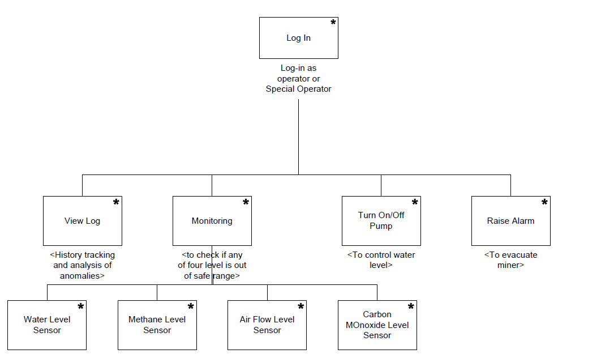

Figure 1 MSCS Overview

The MSCS – as “problem statement” and “objectives” shown above – is a software product designed to provide safety assurance inside a mine. In details, sensors will be equipped at selected places in order to monitor levels of four items: water, methane, airflow, and carbon monoxide. The MSCS will be responsible for automatically collecting data from those sensors to monitor level of these items. Each item has its own safe range defined by “high level point”, “low level point”. The MSCS shall turn a pump on whenever the water in the corresponding sump is reaching the high water level, and off whenever the water is reaching the low water level. In addition, the MSCS shall be responsible for raising alarm and informing the operator within one second, whenever any of methane, airflow, carbon monoxide levels is reaching a critical threshold. Besides, human operators can also control the operation of the pump, like previously, but within limits. An operator can turn the pump on or off while the water is between the low and high water levels. A special operator, the supervisor, can turn the pump on or off without this restriction. The MSCS shall also maintain sensor readings and pump operation records for history tracking and analysis of anomalies.

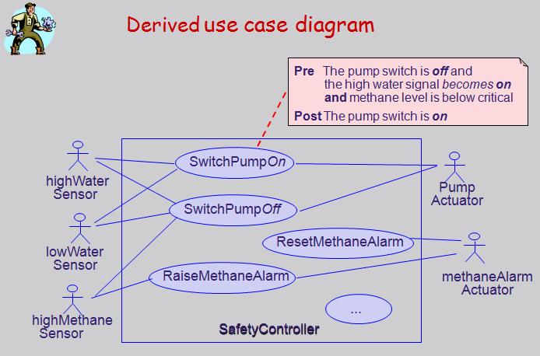

Figure 2 Derived use case diagram

Above “Derived use case diagram” generally show that the MSCS will interact with sensors and has functions to turn on/off pump as well as raise alarm when needed.

## 5.1 Product perspective:

The MSCS shall be developed to automatically control safety inside a mine as well as help authorized operator to control Safety Level correctly and efficiently inside a mine.

## 5.2 Product functions:

The MSCS provides functions as below:

Monitor levels of percolating water, carbon monoxide, methane, and airflow.

Automatically turn a pump *on* whenever the water in the corresponding sump is reaching the *high* water level, and *off* whenever the water is reaching the *low* water level.

Automatically raise alarm, and inform the operator within one second, whenever any of these levels is reaching a critical threshold.

Monitor sensor readings and pump operation records for history tracking and analysis of anomalies.

Allow human operators to control the operation of MSCS with their authorization.

## 5.3 User characteristics:

The MSCS is designed for human operators who are assumed to have the following characteristics:

+ Fully understand the process of Safety Control System and how it is important inside a mine.

+ No special knowledge or skills.

+ No training in computer system use.

## 5.4 Constraints:

The MSCS is a real time system that is responsible for guaranteeing safety level of all the miner and manager, operator inside a mine deep underground. It must operate correctly, accurately and in time.

## 5.5 Assumptions and dependencies:

The MSCS is intended for use inside a mine where may be deep underground leads to the lack of power, light, airflow. In addition, the environment would be under high pressure to ensure the system operating correctly in order to save hundred lives.

## 5.6 Requirements subsets:

None

# 6 FUNCTIONAL Requirements

Dashboard

Planner

Report

Admin

Project Eye

(Product + stages + Deliverables)

Timesheet

DMS

Requirement

Include: Description, Use Case, Use Case scenario

This chapter of the document describes all the functions that the MSCS application shall provide, and how the system operating these functions using natural language and model, chart.

## 6.1 Home Screen

### 6.1.1 Screen Layout

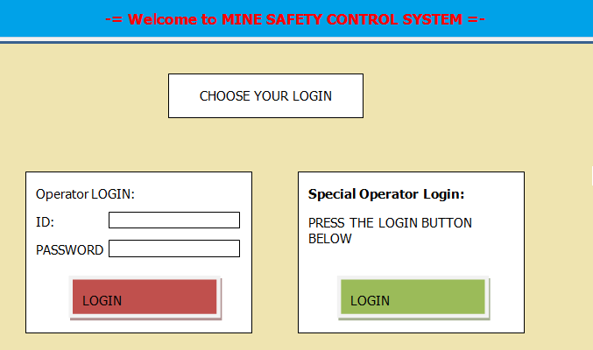

Figure 3 Home Screen

## 6.2 Log-in

### 6.2.1 Screen Layout

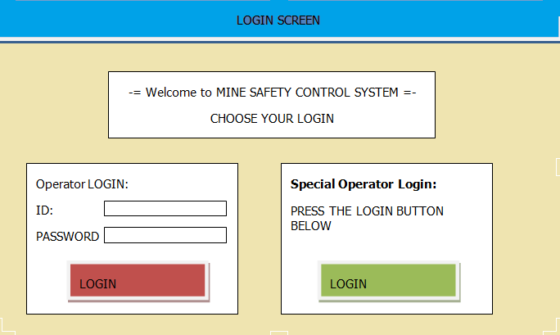

Figure 4 Login Screen

### 6.2.2 Description

This function shall be used to check username and password to log into the system. Only logged in user can use the system.

The MSCS allows Special Operator adding new user, deleting current user, and editing current user’s information.

MSCS shall clearly define Operator or Special Operator with different authorization from Log-in phase.

Users’ attributes shall include:

Table 2 Users' attributes

|  |  |  |
| --- | --- | --- |
| No. | Field name | Remarks |
| 1 | User ID | Each user has a unique identification number |
| 2 | Name | User’s name |
| 3 | Address | User’s publications receiving address |
| 4 | Phone | User’s contact phone number |
| 5 | Position | Position in Organization |
| 6 | Department | Department that user belong to |
| 7 | Working status | Working status : on work or on vacation |

Table 02: Users’ attributes

## 6.3 Log-out

### 6.3.1 Screen Layout

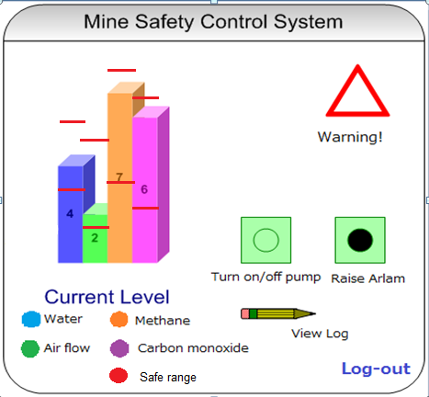

Figure 5 Logout Screen

### 6.3.2 Description

This function provide user to log out the system. Only logged in user can log out the system.

## 6.4 Monitor current level

### 6.4.1 Screen Layout



Figure 6 Monitor Screen

### 6.4.2 Description

This function provide user to monitor Water, Methane, Air Flow, Carbon monoxide Level inside a mine, give warning when the level reach nearby the critical range and allow user to turn on/off pump as well as raise alarm when needed, view log.

Item (Water, Airflow, Methane, Carbon monoxide) Level attributes shall include:

Table 3 Items' attributes

|  |  |  |
| --- | --- | --- |
| No. | Field name | Remarks |
| 1 | Item ID | Each Item has a unique identification number |
| 2 | Name | Item’s name |
| 3 | Description | Item’s description |
| 4 | High Level | Min acceptable level |
| 5 | Low Level | Max acceptable level |
| 6 | Critical range | Critical range |

Table 03: Items’ attributes

## 6.5 Turn on/off pump

### 6.5.1 Screen Layout



Figure 7 Turn on/off pump

### 6.5.2 Description

This function provide user to turn on/off pump to control water level.

Pump actuator can be control automatically by MSCS controller or manually by operators.

Manually By Operators - Use Case 03a:

Name : Turn on/off pump

Goal : Control water level

Actors : All users (include operator and special operator), pump actuator, water sensors

Pre-conditions: Logged user

Post-conditions: None

Main Flow:

Currently in monitor screen

Raise warning to user whenever water level enter critical range

Receive turn on/off pump demand from user

Turn on/off pump as order

Display monitor screen for user keep checking

Automatically by MSCS - Use Case 03b:

Name : Turn on/off pump

Goal : Control water level

Actors : pump actuator, water sensors

Pre-conditions: None

Post-conditions: None

Main Flow:

Currently in monitor screen

Raise warning to user whenever water level enter critical range

Automatically Turn on/off pump by pump actuator whenever water level reach high or low point.

Display monitor screen for user keep checking

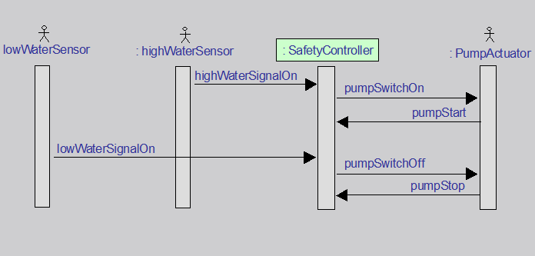

Figure 8 Water sensor operation - Sequence Diagram

## 6.6 Raise alarm

### 6.6.1 Screen Layout



Figure 9 Raise Alarm

### 6.6.2 Description

This function provide user to raise alarm when one of the item’s level out of safe range to evacuate miners.

Alarm actuator can be control automatically by MSCS controller or manually by operators.

Manually by Operators - Use Case 04a:

Name : Raise Alarm

Goal : Evacuate miners

Actors : All users (include operator and special operator), alarm actuator, methane sensors, or airflow sensors, or carbon monoxide sensors.

Pre-conditions: Logged user

Post-conditions: None

Main Flow:

Currently in monitor screen

Raise warning to user when item level enter critical range

Receive raise alarm demand from user

Activate alarm system as order

Save log data into hard drive and display monitor screen for user keep checking

Automatically by MSCS - Use Case 04b:

Name : Raise Alarm

Goal : Evacuate miners

Actors : Alarm actuator, methane sensors, or airflow sensors, or carbon monoxide sensors.

Pre-conditions: None

Post-conditions: None

Main Flow:

Currently in monitor screen.

Raise warning to user when item level enter critical range.

Raise Alarm by alarm actuator whenever one of those level reach high or low point.

Save log data into hard drive and display monitor screen for user keep checking.

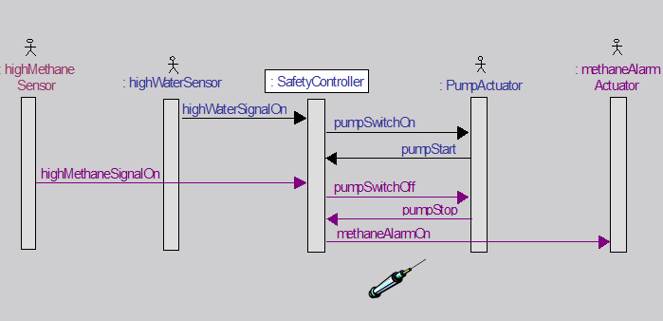

Figure 10 Methane Sensor operation - Sequence Diagram

## 6.7 View Log

### 6.7.1 Screen Layout

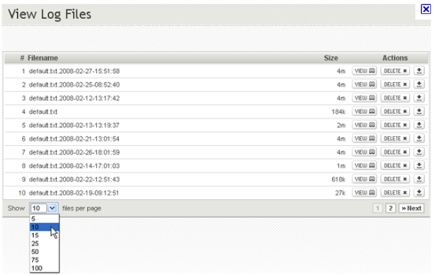

Figure 11 View Log Screen

### 6.7.2 Description

This function provide user to view log of the MSCS.

Use Case 05:

Name : View Log

Goal : Provide log data

Actors : All users (include operator and special operator)

Pre-conditions: Logged user

Post-conditions: None

Main Flow:

Currently in monitor screen

Receive View Log command

Go to View Log screen and display Log data

# 7 Use case model

This chapter describes MSCS’s features and functions using abstract Use Cases and detail scenarios.

A use case is a description of a sequence of actions (including its variations) that the system carries out to create an observable result for an actor.

A scenario is a temporal sequence of interaction events among agent instances.

## 7.1 Actors

Table of all main functions’ actors:

This table indicates which actors associating with which functions.

Table 4 Main functions' actors

|  |  |  |  |  |  |  |  |
| --- | --- | --- | --- | --- | --- | --- | --- |
|  | Main functions | Operator | Special Operator | Water Sensors | Methane, Airflow, Carbon monoxide sensors | Pump actuator | Alarm actuator |
| 1 | Log-in | x | x |  |  |  |  |
| 2 | Log-out | x | x |  |  |  |  |
| 3 | Monitor current level |  |  | x | x |  |  |
| 4 | Turn on/off pump | x | x | x |  | x |  |
| 5 | Raise Alarm | x | x |  | x |  | x |
| 6 | View Log | x | x |  |  |  |  |

Table 04: Main functions’ actors

## 7.2 Use cases

This table list all use cases for each corresponding system functions.

Table 5 Use cases List

|  |  |  |
| --- | --- | --- |
| System Functions | Main Use Cases | Use Case ID |
| Log-in | | |
|  | Log-in Use Case | UC_1.1 |
| Log-out | | |
|  | Log-out Use Case | UC_1.2 |
| Monitor current level | | |
|  | Monitor current level Use Case | UC_1.3 |
| Turn on/off pump | | |
|  | Manually turn on/off pump Use Case | UC_1.4a |
|  | Automatically turn on/off pump Use Case | UC_1.4b |
| Raise Alarm | | |
|  | Manually raise alarm Use Case | UC_1.5a |
|  | Automatically raise alarm Use Case | UC_1.5b |
| View Log | | |
|  | View Log Use Case | UC_1.6 |

Table 05: Use cases List

## 7.3 Main Use Case Diagrams of the MSCS

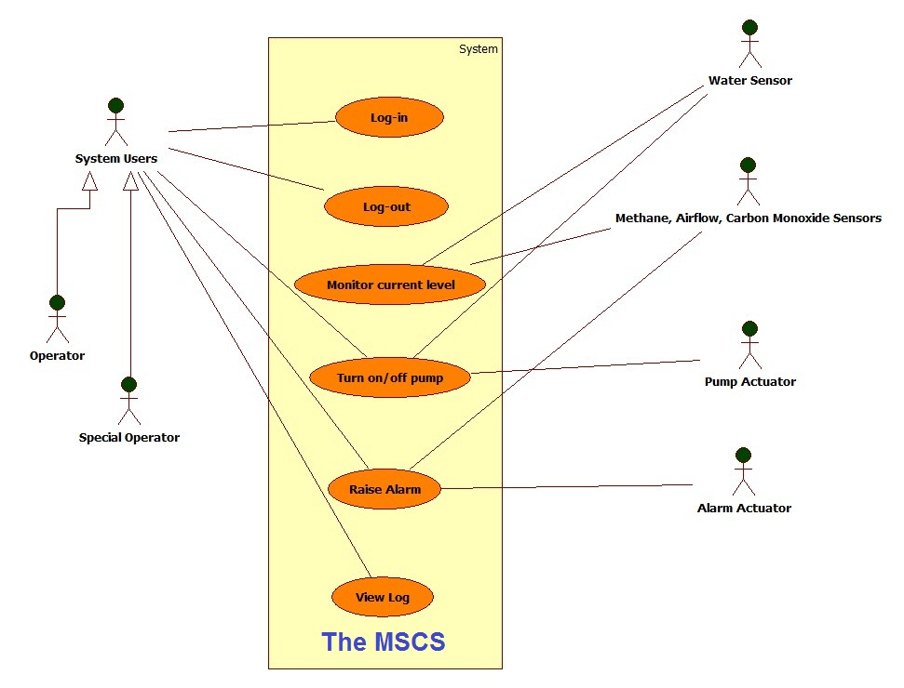

Figure 12 Main Use Case Diagrams of the MSCS

This main Use Case Diagrams of the MSCS show all main functions placing inside the system boundary and all actors that associate with those functions.

## 7.4 Log-in

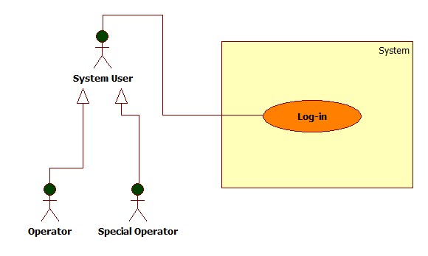

Figure 13 Log-in Use Case model

Use Case scenario:

Table 6 Log-in scenario

|  |  |  |
| --- | --- | --- |
| User Case ID | UC_1.1 | |
| Name | Log-in Use Case | |
| Goal | Authenticate operators then authorize them. | |
| Actors | Operator (include special operators) | |
| Pre-conditions | None | |
| Post-conditions | None | |
| Main Flow | 1. Users run MSCS Application.  3. Users enter user’s information: Username, Password and hit “Log-in” button. | 2. Display Home Screen and request user to log in.  4. Validate user’s information.  5. Display monitor screen to corresponding user. |
| Exception | If username or password is not correct, the MSCS will show error message and ask user to log in again. | |
| Open Issues | N/A | |

Table 06: Log-in scenario

## 7.5 Log-out

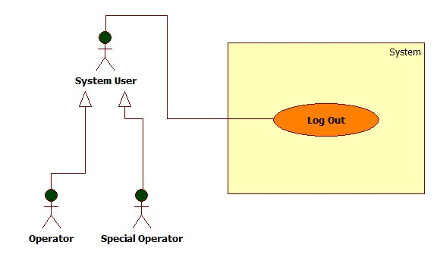

Figure 14: Log-out Use Case model

Use Case scenario:

Table 7 Log-out scenario

|  |  |  |
| --- | --- | --- |
| User Case ID | UC_1.2 | |
| Name | Log-out Use Case | |
| Goal | Provide Log-out function for User to check out | |
| Actors | Operator (include special operators) | |
| Pre-conditions | Logged user | |
| Post-conditions | None | |
| Main Flow | 1. Users are using MSCS and click “Log-Out” button. | 2. Log user out and display Home Screen. |
| Exception | None | |
| Open Issues | N/A | |

Table 07: Log-out scenario

## 7.6 Monitor current level

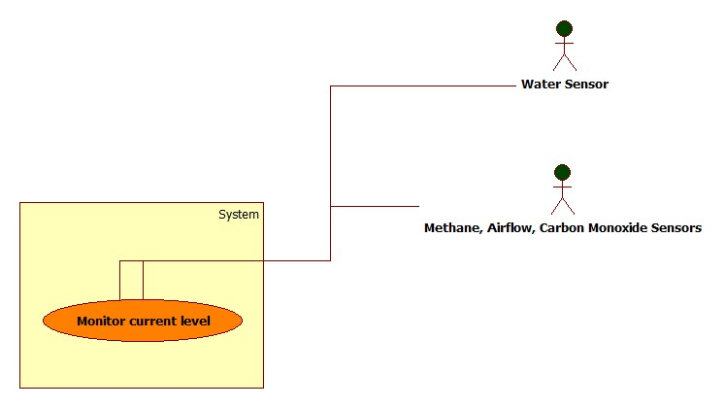

Figure 15 Monitor current level Use Case model

Use Case scenario:

Table 8 Monitor current level scenario

|  |  |  |
| --- | --- | --- |
| User Case ID | UC_1.3 | |
| Name | Monitor current Level Use Case | |
| Goal | Monitor items’ level by keep receiving data from sensors and display statistics in monitor screen. | |
| Actors | Water sensors, Methane, Airflow, Carbon monoxide sensors | |
| Pre-conditions | System active | |
| Post-conditions | None | |
| Main Flow | 1. Sensors keep sending data. | 2. Receiving data and display statistics by graph in monitor screen. |
| Exception | None | |
| Open Issues | N/A | |

Table 08: Monitor current level scenario

## 7.7 Turn on/off pump

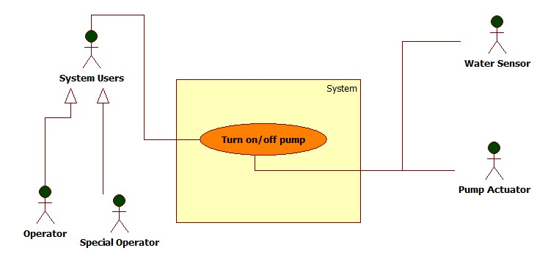

Figure 16 Turn on/off pump Use Case model

Use Case scenario:

Table 9 Turn on/off pump scenario

|  |  |  |
| --- | --- | --- |
| User Case ID | UC_1.4-a/b | |
| Name | Manually /Automatically Turn on/off pump Use Case | |
| Goal | Turn on/off pump to control water level | |
| Actors | Operator (include special operators), water sensors, pump actuators | |
| Pre-conditions | Logged users, water level data measured by sensor is reaching High or Low point | |
| Post-conditions | None | |
| Main Flow | 1. Water sensors send data  3a. Operator hits “Turn on/off pump” button.  3b. No respond from operator  5. Pump actuators receive and perform the task. | 2. Receive data, display statistics graph. Water level reach High or Low point. Issue a warning.  4a. Receive command and send command to Pump actuators  4b. Automatically send command to Pump actuators |
| Exception | 3a go with 4a as well as 3b followed by 4b. | |
| Open Issues | N/A | |

Table 09: Turn on/off pump scenario

## 7.8 Raise Alarm

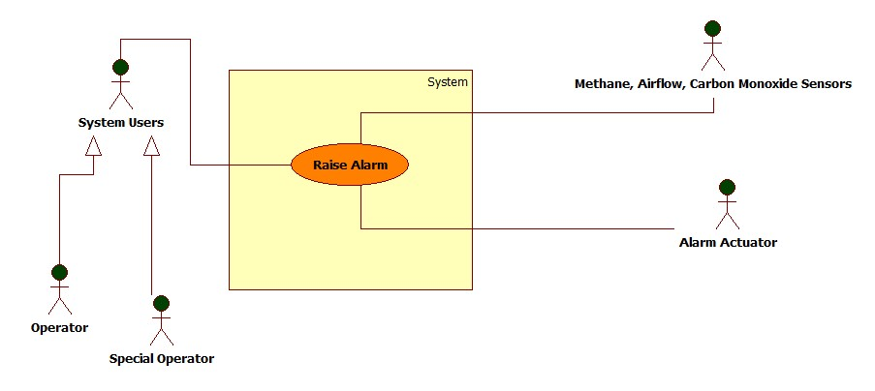

Figure 17 Raise alarm Use Case model

Use Case scenario:

Table 10 Raise alarm scenario

|  |  |  |
| --- | --- | --- |
| User Case ID | UC_1.5-a/b | |
| Name | Manually /Automatically Raise Alarm Use Case | |
| Goal | Raise Alarm when items’ level reach High or Low point to evacuate miners. | |
| Actors | Operator (include special operators), Alarm Actuator, Methane – Airflow – Carbon monoxide sensors | |
| Pre-conditions | Logged users, Methane or Airflow or Carbon monoxide level data measured by sensors is reaching High or Low point | |
| Post-conditions | None | |
| Main Flow | 1. Sensors send data  3a. Operator hits “Turn on/off pump” button.  3b. No respond from operator  5. Alarm Actuators receive and perform the task. | 2. Receive data, display statistics graph. Methane or Airflow or Carbon monoxide level reaches High or Low point. Issue a warning.  4a. Receive command and send command to Alarm Actuators  4b. Automatically send command to Alarm Actuators |
| Exception | 3a go with 4a as well as 3b followed by 4b. | |
| Open Issues | N/A | |

Table 10: Raise alarm scenario

## 7.9 View Log

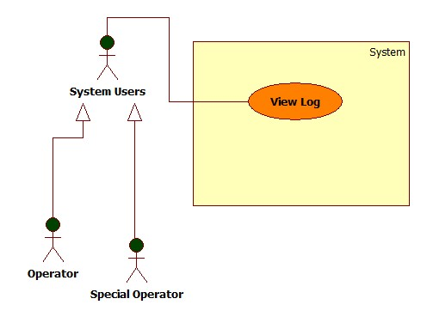

Figure 18 View log Use Case model

Use Case scenario:

Table 11 View log Scenario

|  |  |  |
| --- | --- | --- |
| User Case ID | UC_1.6 | |
| Name | View Log Use Case | |
| Goal | Provide View Log function for sensor readings and pump operation records for history tracking and analysis of anomalies. | |
| Actors | Operator (include special operators) | |
| Pre-conditions | Logged user | |
| Post-conditions | None | |
| Main Flow | 1. Users are using MSCS and click “View Log” button. | 2. Display Log View Screen. |
| Exception | None | |
| Open Issues | N/A | |

Table 11: View log scenario

# 8. NON-FUNCTIONAL Requirements

This chapter of the document describes all the non-functions requirement of the MSCS.

The MSCS’s usability, availability, performance are very important factors to ensure that the system operate effectively and keep hundred miners safe.

## 8.1 Usability

The MSCS usability is the key factor to ensure that the system run exactly as well as the operators can control the system efficiently.

The MSCS application shall provide clear, friendly and easy interface to operate so that system users have to spend no more than one hour learning to use the system.

### 8.1.1 Background knowledge

MSCS users are assumed to have very basic knowledge at using computer systems.

### 8.1.2 Training

Operators’ training time requirement: 60 minutes.

## 8.2 Reliability

### 8.2.1 Availability

Whenever the mine is during operation time no matter how many people working inside, the MSCS has to be ON.

### 8.2.2 Mean Time between Failures (MTBF)

Mean Time between Failures (MTBF): more than 6 months.

### 8.2.3 Mean Time to Repair (MTTR)

Mean Time To Repair (MTTR): less than 48 hours.

### 8.2.4 Accuracy

Accuracy: 100%

### 8.2.5 Maximum Bugs and Defect Rate

Maximum Bugs and Defect Rate: 0.3 bugs per thousand lines of code (0.3 bugs/KLOC).

### 8.2.6 Critical Bugs

Critical bugs:

+ Loss of Log: No

+ Unable to operate any function: No

## 8.3 Performance

### 8.3.1 Response Time

Response time for a respond:

Average: 50 milliseconds

Maximum: 80 milliseconds

### 8.3.2 Capacity

Only one operator at the same time.

### 8.3.3 Resource utilization

Memory:

+ 512 MB of RAM

Operating System:

+ Microsoft Windows XP or newer version

+ Mac OS X 10.0 or newer version

+ Linux 3.5 or newer version

## 8.4 Supportability

### 8.4.1 Coding standards

According to “Standard Java Coding Convention”

– 09be-HD/PM/HDCV/FSOFT - Version 1/1.

### 8.4.2 Maintenance Utilities

Support working hours phone call technical support: 8:00 to 16:00 from Monday to Friday.

## 8.5 Design Constraints

Coding standard:

+ This application will be developed in Java programming language, version J2EE 6.

Software process requirements:

+ The software process shall confront to the CMMI 5 standard.

Developmental tools:

+ This application will be developed using NetBeans from Sun Microsystems, version 6.5.

### 8.5.1 Software Languages

GUI , Help documents, all other support documents are in English.

### 8.5.2 Software Process Requirement

The software process has to meet the CMMI 5 standard.

### 8.5.3 Development Tools

The MSCS shall be developed using Eclipse 3.6 , SQA activity using FSOFT template and j-unit.

## 8.6 On-line User Documentation and Help System Requirements

The deployment of the application shall be provided by a technical agent include full help document for user.

## 8.7 Purchased Components

None

## 8.8 Interfaces

### 8.8.1 User Interfaces

As shown in Functional requirements – chapter 6

8.8.2 Hardware Interfaces

API to interact with sensors are provided in advance.

## 8.9 Licensing Requirements

The MSCS is only applicable for Mine Safety Control Department, which legally buy this product. No other use is legal.

## 8.10 Legal, Copyright, and Other Notices

This MSCS is protected under the national law of copyright.

## 8.11 Applicable Standards

The system shall confront to the ISO 90003:2001 standard.

# 9. Supporting Information

**List of figures**:

Figure 1 MSCS Overview 8

Figure 2 Derived use case diagram 9

Figure 3 Home Screen 11

Figure 4 Login Screen 12

Figure 5 Logout Screen 13

Figure 6 Monitor Screen 14

Figure 7 Turn on/off pump 15

Figure 8 Water sensor operation - Sequence Diagram 17

Figure 9 Raise Alarm 17

Figure 10 Methane Sensor operation - Sequence Diagram 18

Figure 11 View Log Screen 19

Figure 12 Main Use Case Diagrams of the MSCS 22

Figure 13 Log-in Use Case model 23

Figure 14: Log-out Use Case model 24

Figure 15 Monitor current level Use Case model 25

Figure 16 Turn on/off pump Use Case model 26

Figure 17 Raise alarm Use Case model 27

Figure 18 View log Use Case model 28

**List of tables:**

Table 1 Abbreviations 6

Table 2 Users' attributes 12

Table 3 Items' attributes 14

Table 4 Main functions' actors 20

Table 5 Use cases List 21

Table 6 Log-in scenario 23

Table 7 Log-out scenario 24

Table 8 Monitor current level scenario 25

Table 9 Turn on/off pump scenario 26

Table 10 Raise alarm scenario 27

Table 11 View log Scenario 28